Masculinity in Advertising Unit

ACTIVITY 1 – Today Monday May 30th, 2022 (individually)

If you have earbuds/headphones, use them and check out this trailer -> https://www.youtube.com/watch?v=hc45-ptHMxo

Answer the following questions based on your perceptions – do NOT give me what you think Mr Sangha wants to hear:

- What immediate thoughts come to mind while viewing this?
- How did the images or thoughts presented make you feel?
- What do you think the phrase “Be a Man” means to you?
- Do you agree with the sentiment presented by the video?

Email to me rsangha@sd38.bc.ca

ACTIVITY 2 – Today Monday May 30th, 2022 (individually)

Read over Activity 3 in order to understand this activity.

Not all ads targeted at males focus on the six themes in Activity 3. Look for a commercial online (a real commercial, not a parody etc) that promotes a more positive or realistic image of masculinity. Post the link in a Word doc (check to make sure that it is linked properly). Explain in a paragraph your reasoning as to why this is a positive ad. DO NOT pick the same ads as the neighbours around you as I will be periodically checking.

ACTIVITY 3 – Wednesday June 1st , 2022 (individually)

Find an original online print ad for each of the themes below and post each into a word document. Explain why you feel the ad you chose fits the particular theme in a paragraph or two. Examples are included – do not pick the same company.

Common themes encoded in mainstream ads geared towards males.

- Attitude is Everything

Most often in ads geared to young men. Be a rebel. Attitude is packaged as a cool, desirable trait. Encourage “in your face” behaviour bordering on violent.

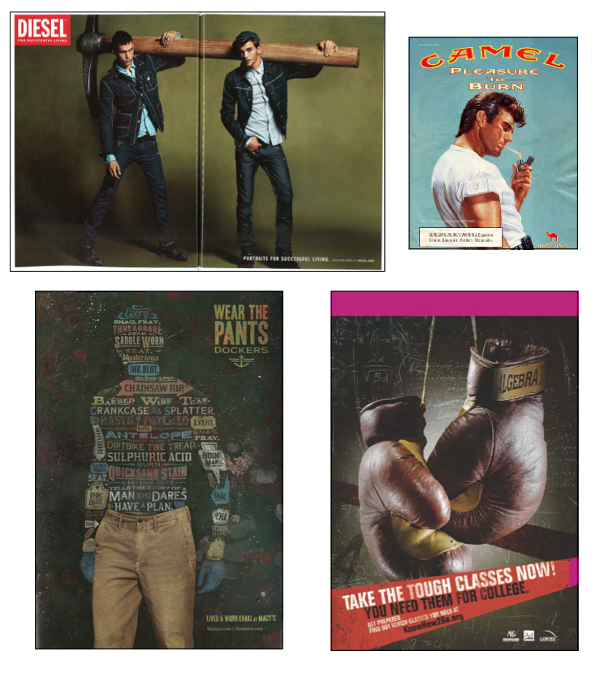

- Cave Man Mentality

Use of violent male icons/heroes from popular history to demonstrate masculinity. Gladiators, pirates, warriors, cowboys, etc. Message is men have always been aggressive (part of their nature). Product is associated with manly needs.

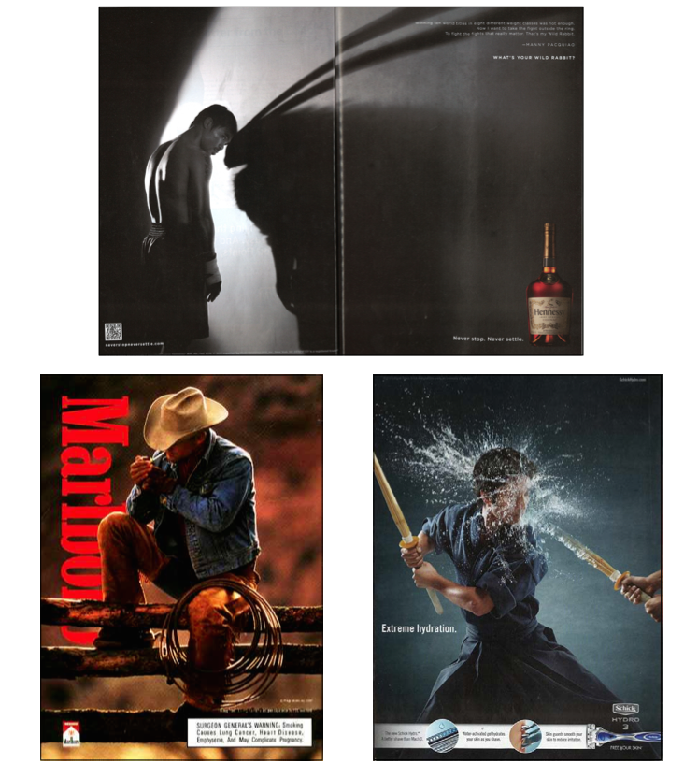
- New Warrior

Use of uniformed military or sports figures with weapons or gear to enhance the manliness of products to young boys and adolescent males. Violence is cool, acceptable, adventurous. Usually traditional male products like beer, running shoes or deodorants.

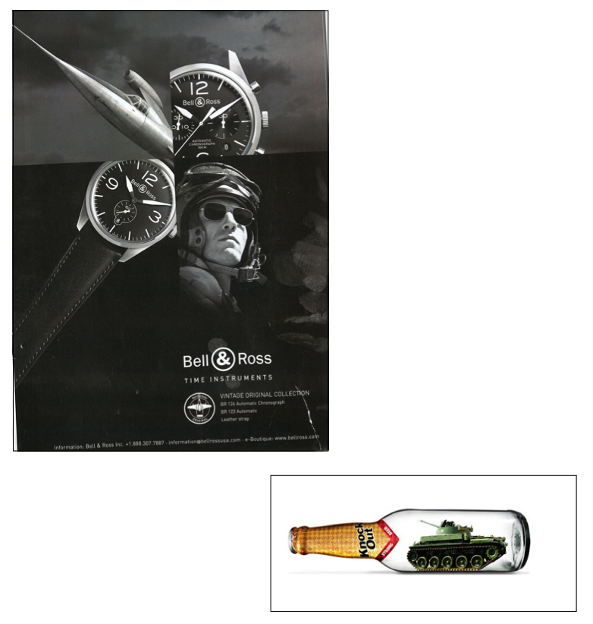

- Muscles/Ideal Man

Rippling muscled body = ideal male. Dominance and control. Women in ads are fawning over men. Many found in sports magazines. Products could be financial institutions or cars.

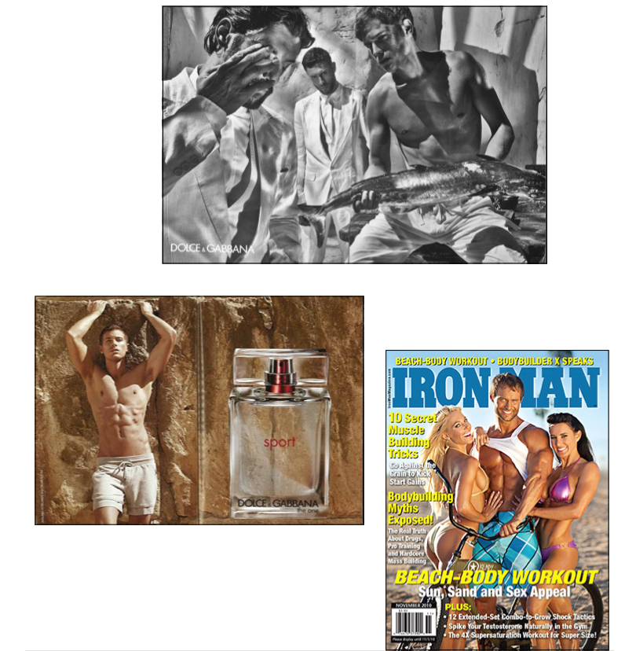

- Heroic Masculinity

Usually movie ads. Heroic male lead. Women are byproducts. Glamourization of the violence in the movie. Guns/weapons used to show the strength/masculinity of the males.

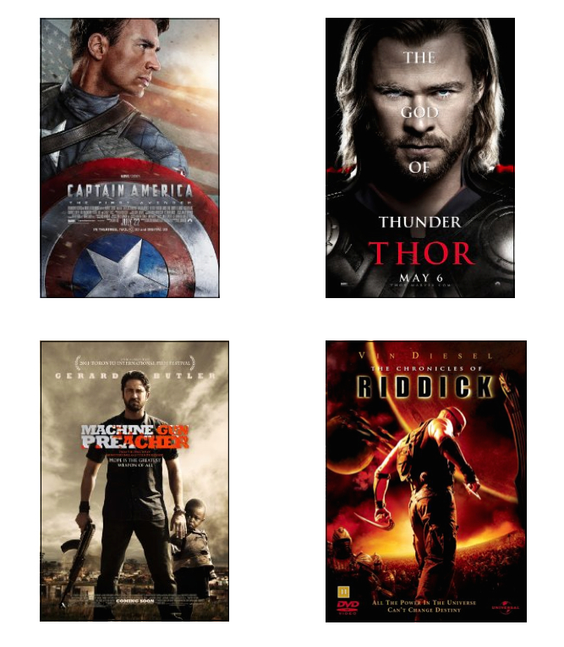

- Censuring Un-Masculinity

Defining masculinity by associating with what it isn’t and what a man shouldn’t be. Deviating from what is masculine defines that you are not masculine.

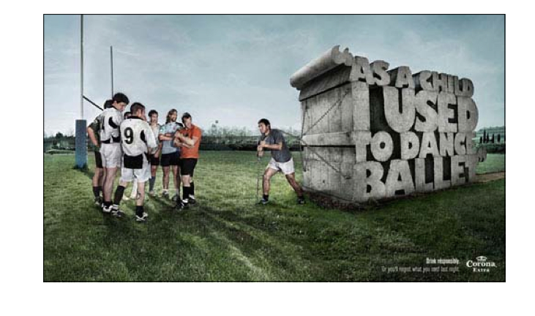

ACTIVITY 4 – Monday June 6th, 2022 beginning of class (groups of 2 or 3 – no individuals)

Saturday Night Live does some great parody videos of real and fake commercials. Check some of those out. Also check out former McNair student Max Blanche’s video for this assignment on my website.

Choose one of the aforementioned 6 themes and create a parody commercial of 45 seconds (+/- 10 seconds). If you star in it, better marks for your group.

A storyboard (either on paper or using storyboardthat.com) needs to be handed in on Thursday June 2nd, 2022.

This is a project marked as follows:

45 +/- 10 seconds |  |  | /3
1 of 6 themes |  |  | /3
Editing |  |  | /3
Music choice |  |  | /3
Sound Quality |  |  | /3
Product Placement |  |  | /3

