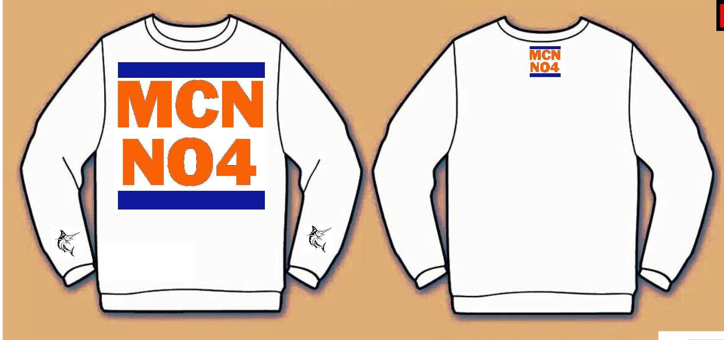
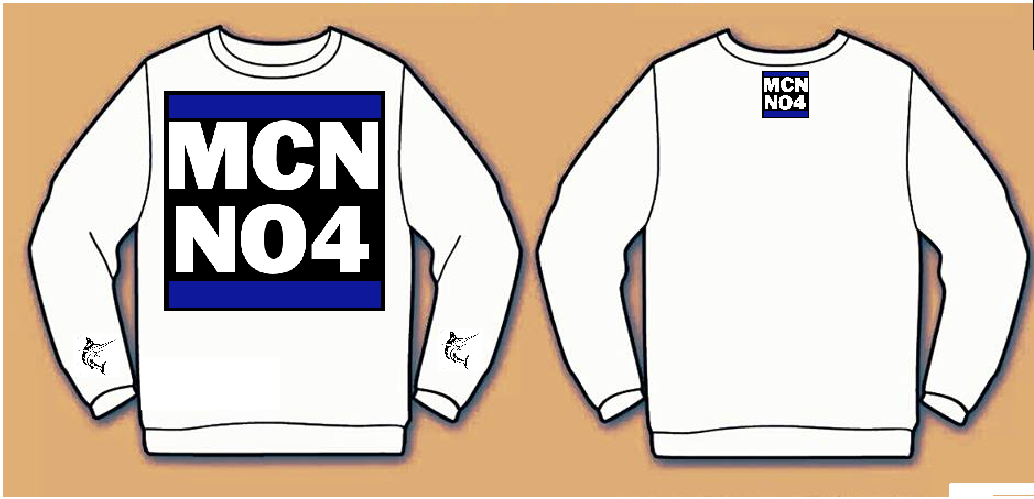
New Style: Base colour can also be grey or black, marlins will be embroiled on Black or white depending on base coat

Grade 7: Base colour can also be black or grey, marlin on the back will be embroiled on
