Cereal Box Design Project

Cereal boxes are designed to appeal to a TARGET AUDIENCE/MARKET: the group that the cereal is intended for.

They generally have the same components.

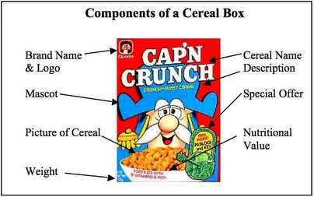

Colours of the box are harmonious (tend to go together). Colours used vary depending upon the Target Audience. Children’s – generally bright primary or secondary colours.

Design is also focused around the Target Audience. Compare below.
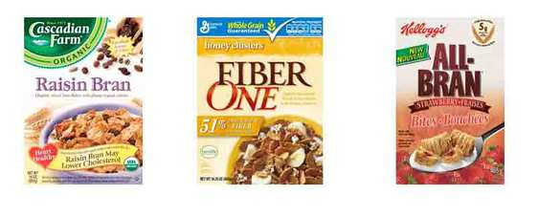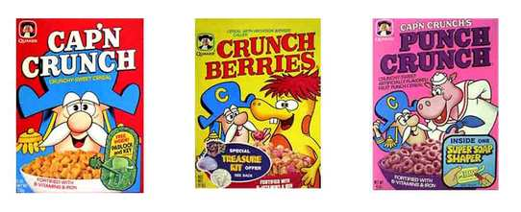
Project – there is a written component and a physical design component.

A – Who is your target audience? Gender, age, lifestyle etc (minimum 7 variables – look at Customer Profile notes from last year or from a Marketing 11 student). Explain each variable? This write-up is to be completed and attached to your submitted work.

B – Explore various fonts that would fit your target audience. Research online and then choose one – explain why it was selected in relation to your target. Come up with an appealing name for your cereal that will also target your audience. Test the name and font by asking others what comes to mind. On your write-up, include why you selected the name.

C – Image search for or create your own bowls of cereal that may fit your audience. Once selected/designed, explain your choice.

D – Image search for or create your own characters/people/mascots to fit your cereal. On your write-up, include why you selected them for your audience.

E- Choose colour themes and any other extra items/text. On your write-up, include why you selected those items/texts.

E – Put all elements together and design a 3 dimensional box. See an example below OR go to the display windows by the doors near Mr Chan and Ms Blair’s room.

This box will be submitted at the end of Friday March 4th’s class. Bonus marks are possible.

